**Weed plant detection from agricultural field images**

**Problem statement**

Weed plant detection is a new research problem in agricultural field which want to take help from computational science to detect unwanted growth of weed along with other crops/plants. Usually in farming when we farmers grew something due to soil property and pre available micro seeds additional growth of weeds is there which spoil the actual outcome of farming as they affect the growth of planted plants. So weed detection is problem of accurately identifying the area of weeds so that specific areas can be targeted for spraying with minimum spraying on the other plants of interest. In recent years, as the world population growth, existing land and natural resources decreased, the precision agriculture is increasingly capturing more attention of the researchers. Image processing approaches could be applied to solve this problem.

**Background**

With increase in worldwide population, although we have sufficient farm products but there is need of new smart farming methods to increase or maintain crop yield while minimizing environmental impact. Precision agriculture techniques achieve this by spatially surveying key indicators of crop health and applying treatment, e.g. herbicides, pesticides, and fertilizers, only to relevant areas. Here, robotic systems can be often used as ﬂexible, cost efficient platforms replacing laborious manual procedures. Speciﬁcally, weed treatment is a critical step in autonomous farming as it directly associates with crop health and yield.

**Challenges:** Reliable and precise weed detection is a key requirement for effective treatment as it enables subsequent processes, e.g. selective stamping, spot spraying, and mechanical tillage, while minimizing damage to surrounding vegetation. However, accurate weed detection presents several challenges. Traditional object-based classiﬁcation approaches are likely to fail due to unclear crop-weed boundaries, as exempliﬁed in Figure given below. This aspect also impedes manual data labeling which is required for supervised learning algorithms.

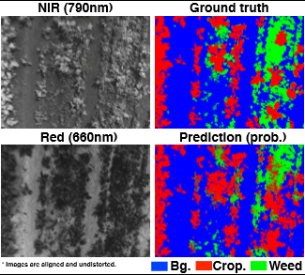

**Methodology**

Literature proposes that weeds detection method can be based on position and edge features. The weeds which are under target can easily, rapidly and accurately separated from the background. In this way we can solve many technical problems related to precise pesticide and in farmland vehicle navigations system.

Usually the weeds image contains three elements of soil, crops and weeds. Therefore, the weed detection method which the literature proposed is divided in three steps, that is soil background segmentation, crop elimination and weeds extraction.

The proposed approach is based on change in color of soil background, plants and crop weed pictures. These images consist of Red green and blue component. Three components (RGB) of the image are combined according to certain combination ( 2*G-R-B) to make original image. If the image is changing gray, then the gray intensity of the green crops is increased and soil background be restrained. On the other hand, the difference of gray intensity is expanded. In this case suitable segment threshold is used. The threshold are used to segment the gray images. RGB 3-component combination method shown as follows:

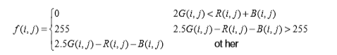

In the formula, R(i,j), G(i,j), B(i,j) are distinguished represent the value of RGB 3-component of point (i,j). f(i,j) is the gray value after image changing gray.

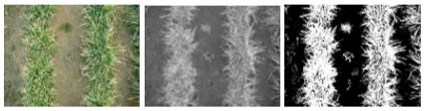

After green plant is separated from soil background, the next step is to extract inter-row weeds from plant pixels. Due to the green color both the crops and weeds represent, it is difficult to separate them through color feature. There are leaf folded and occluded situation between crops and inter-row weeds, so it also have certain difficulties to indentify inter-row weeds using shape or texture feature. According to the position feature that drilling crops are arranged in rows and row ledge is basically fixed, an effective approach to identify inter-row weeds of drilling crops is provided.

The approach of weed detection based on position and edge feature is: Firstly, the pixel histogram method to set centerline of crop rows, through the Roberts edge detection operators the edge of crop row is marked. Then starting from the pixels of crop centerline, the pixels are determined belonging to crops or weeds through analysis according to distinguished rows both right and left, until it reaches the edge of crop row.

**Experimental Design**

Crop pixels elimination method introduces sliding window and through the calculating of the number of black and white pixels in the window to decide whether it reaches the edge of crop area The problem can be resolved through the analysis of the total number of white pixels Sw and black pixels Sb in window. Algorithm process is shown as follows:

1) Detect edge of the binary image

2) Set a window W’ (3×3 or 5×5 etc),

3) Set distance parameters like minimum distance, Maximum distance (dmax) , progressively scan binary image with W.

4) Calculate the total number Sw of white pixels in sliding window.

5) If Sw of W is less than threshold M and the distance between point C and centerline dc>dmin, meanwhile C is the boundary point detected in step (1) continue the current line determination because it doesn’t reach the edge of crop area. Repeat steps (4) and (5) until the cease conditions are met.